**W05 Team Activity - SQL Select Practice**

**Team Activity 05**

**Question 1: How many students are enrolled in the Database Systems course?**

**Team Member:** Adeshina

**SQL Query:**

SELECT COUNT(*) AS total_students

FROM enrollment

WHERE course_id = (SELECT course_id FROM courses WHERE course_name = 'Database Systems');

**Query Results:** 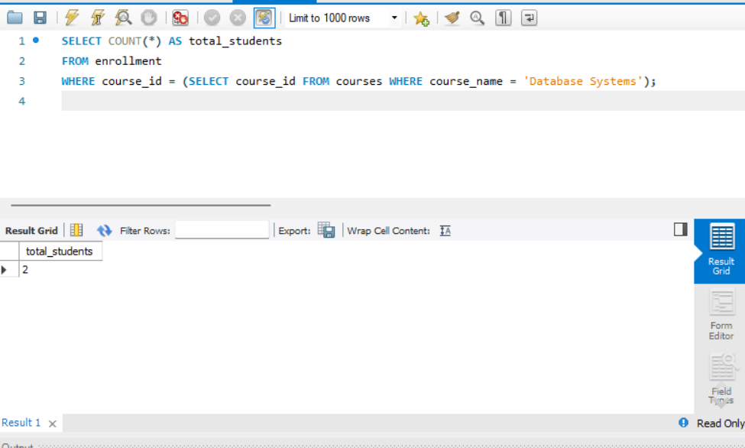

**Question 2: What are the names of students along with their enrolled course titles?**

**Team Member:** tom

**SQL Query:**

SELECT students.student_name, courses.course_name

FROM students

JOIN enrollment ON students.student_id = enrollment.student_id

JOIN courses ON enrollment.course_id = courses.course_id;

**Query Results:** 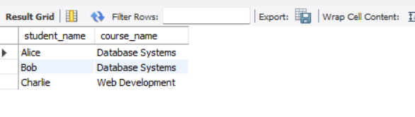

**Question 3: What is the average grade of students in the Web Development course?**

**Team Member:** John

**SQL Query:**

SELECT AVG(grades.score) AS average_grade

FROM grades

JOIN enrollment ON grades.enrollment_id = enrollment.enrollment_id

JOIN courses ON enrollment.course_id = courses.course_id

WHERE courses.course_name = 'Web Development';

**Query Results:** 